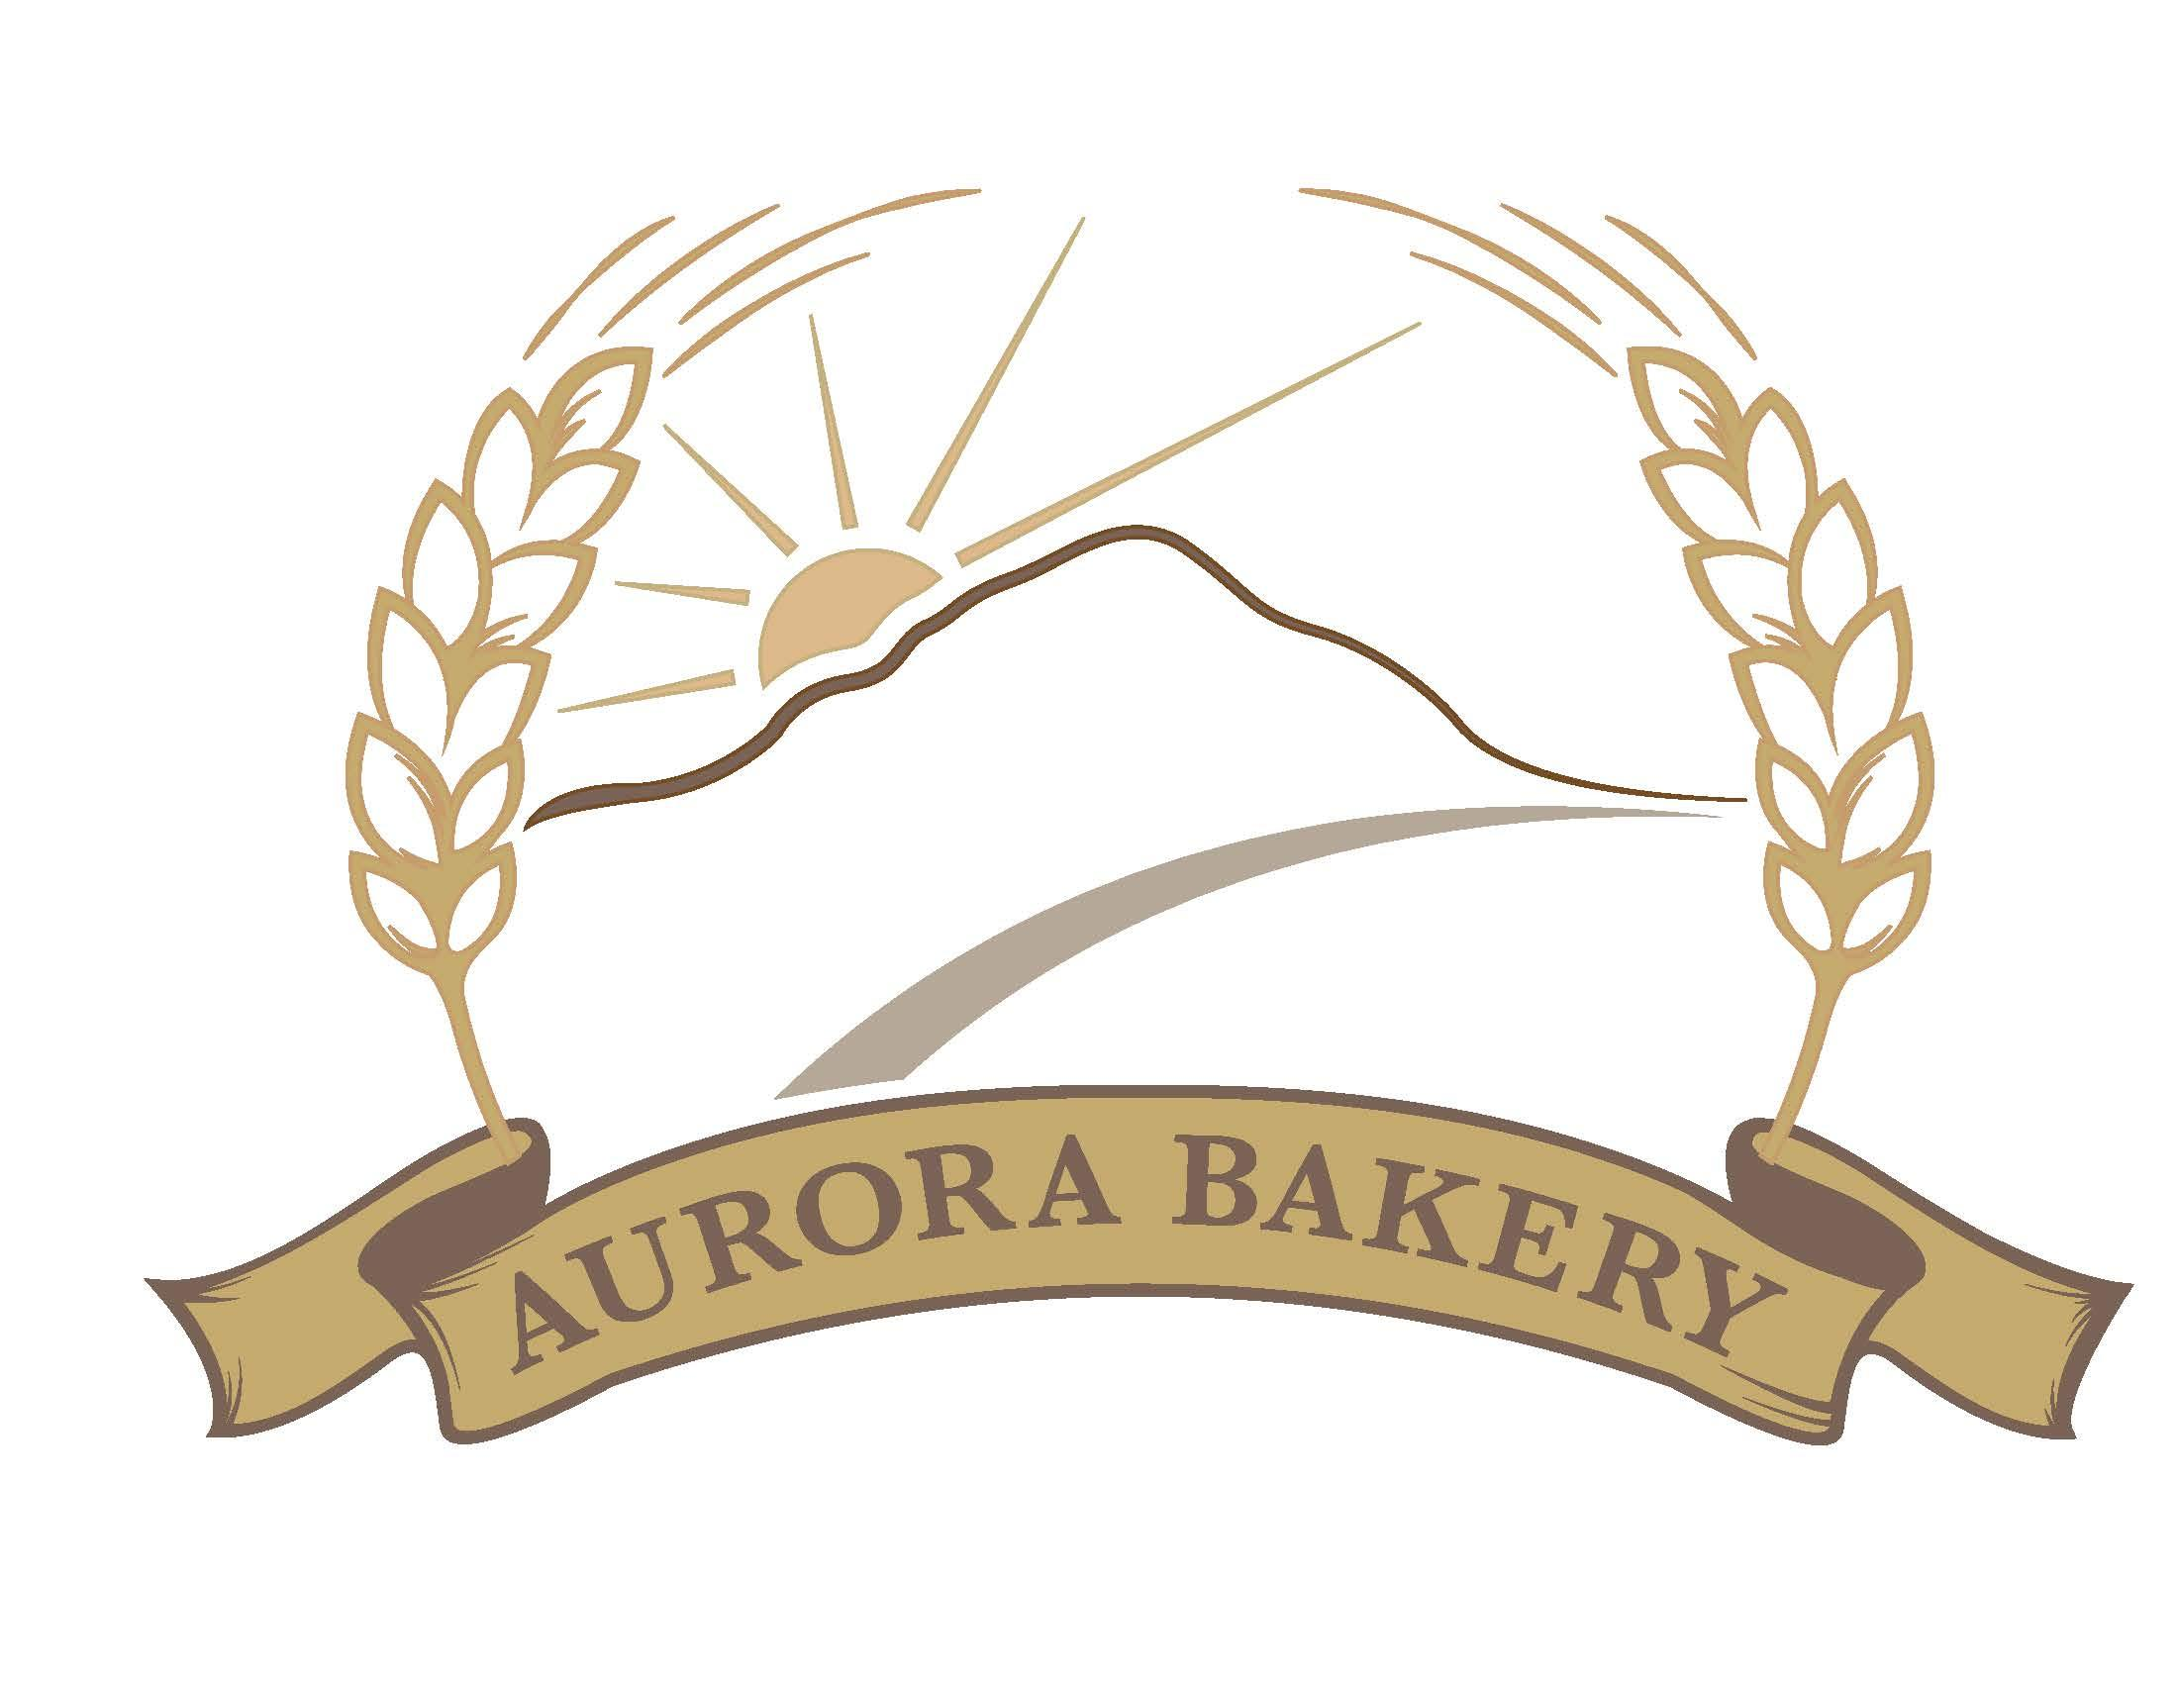Thanksgiving Menu
Place your order by visiting us at 29 Main St, Newport or online at auroraonlineordering.square.site by Nov. 16th, 2022.
Pies- $22/ea
Traditional Apple
Apple Crumb
Apple Cranberry
Pecan
Chocolate Pecan
Pumpkin

Cakes- priced by size
Apple Caramel Cake
Pumpkin Spice Cake
Butternut Squash Roll
Pumpkin Cheesecake

Dinner Rolls- 12 for $8
Herb
Honey Wheat
White

